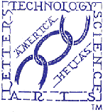 | THE HELLENIC LINK, Inc.  ΕΛΛΗΝΙΚΟΣ ΣΥΝΔΕΣΜΟΣ  Member Update- BULLETIN  Editorial Committee: Ahilleas Adamantiades, Evangelia Georgoulea,  Maria-Eleftheria Giatrakou, Dean C. Lomis, Katherine Efthymiatou-Stabile  Contributing Editor: Dimitrios Oreopoulos Acting Editor: Constantine Efthymiou  No. 78, April-May 2009
Our Paschal Message of 2009
The traditional Resurrection Greetings of the Hellenic Link to members, friends and indeed everyone come this year in a unique, unprecedented way. Actually, our Greetings in the form of an interview(see also Bulletin No.77) were part of a composite message broadcasted to Hellenes everywhere from the Municipal Radio of Athens 984FM on Good Saturday, April 18, 2009. The message included contributions from a culturally and vocationally cross-section of Hellenes on both sides of the Atlantic. Representatives of the Church, of the academic communities of the USA and Greece, groups of children and adults triumphantly chanting hymns of the Resurrection of Christ, as well as the commentators, conducting the interviews from the studio in Athens all took part. The basic message transmitted? The triumph over evil and the liberation from the shackles of death, the unspeakable happy experience of individuals ready to accept this spiritual new order in the world. Beyond it, but in the same spirit, there was a collective expression of hope through enlightened action, for an ethnic resurrection in matters of vital concern, such as the preservation of the Hellenic cultural identity and the proper education of our children.

The almost hourly message is accessible and audible on the internet: www.athina984fm.gr , by clicking on Program and selecting the Saturday 5:00 p.m. broadcast “Με Παρρησία, Ελληνικά” (Outspokenly in Greek) of Anna Valavanidou. There, you will find archived separate records of the weekly broadcasts. The latest, at the time of this writing, is the Paschal broadcast of 4/18/09.

The Hellenic Link is happy that it had the opportunity to participate in the Celebration of the Pasha of the Greeks and to report on some of its own cultural activities on behalf of the common good.

NEWS FOR AND ABOUT THE LINK

Guide for Study in Greece: Its Development Status
We acknowledge with deep appreciation receipt of a compendium resource for studies in Greece prepared specially for the Hellenic Link, particularly for the needs of its Advisory Council on Hellenic Education, by the Corgialenios Library in Cephalonia (see earlier report in Bulletin 73, November 2008). This resource was compiled for the purpose of facilitating studies by North American students at Greek universities, thanks to the painstaking collaboration of Mr. Elias Toumasatos, the Director of the Library.
The resource contains comprehensive information on all programs of study in the fields of Humanities and Education currently offered by the universities of Greece. Included are descriptions of programs with the offered courses, as well as data on teaching and research faculties with their areas of research concentration and publications. Examples of fields covered are: Philology (Ancient, Byzantine and Modern Greek Literature), History, Archaeology, Philosophy, History of the Art, and Theater Studies. We hope that the resource in its final version will be technically handy to provide ready assistance to American students interested in taking courses relevant to their program or seeking opportunities to do academic research in Greece. Faculty in American institutions advising students might also find the resource useful for the same purpose.
Future announcements will provide guiding instructions for the utilization of the resource.

Invitation Extended to HLand HMS of NY to Assist in a Significant National Outreach Project

The Hellenic Link, Inc. and the Hellenic Medical Society of New York have received an appeal for support from a civic group in Greece. The group known in Greece as “Η Ομάδα του Αιγαίου” (The Aegean Team) includes as members medical doctors of various specialties, as well as other professionals; for 15 consecutive years, they have been engaged in outreach medical and cultural assistance of the inhabitants of Agathonisi, Koufonisi, Leipsoi, Fournoi and other small isles in the Eastern Aegean, having population of less than 3000. These outpost - island Greeks are essentially isolated from the rest of the country
(with whatever this means for medical emergencies, ordinary healthcare and other human needs), as they lack regular connection with the larger islands in the Aegean and with the mainland by passenger ship or otherwise. According to information we have received, the assistance offered by the above group, delivered by its own motorboats (see picture on page 5), is substantial. In every case, it is eagerly awaited, received, utilized and widely appreciated. As requested, we have been in consultations with the Hellenic Medical Society of NY for the purpose of providing jointly all possible assistance to our hard pressed compatriots. We hope, soon we will be able to announce a program of support and collaboration with the Aegean Team.

Interaction and Cooperation with the HMS of NY
Ongoing contacts between the Boards of the HL and the HMS of NY are focused, among other matters, on possiblet endeavors for the development and planning of joint cultural, scientific and other professional events in the community. Immediate goals in the present discussions are:
- Co-sponsorship of public lectures on topics of general interest and significance.
- Participation in projects aimed at strengthening programs of Hellenic Education
- Inquiry into the existence of a potential for joint publication of Hellenic cultural and scientific works.

The HL Presence in the HERMES EXPO 2009
Our Association was well represented by a contingent of HL members at the Annual event of Hermes EXPO in Atlantic City, NJ on April4 4, 2009. From a dedicated booth, our representatives had the opportunity to present orally and with printed information the Objectives and Activities of the HL to many visitors of the EXPO as they met and initiated development of working relationships with other Hellenic Organizations and had contacts for the purpose of mutual enlightenment with Greek American leaders as well as visiting officials from Greece. Our emissaries at this event included the President, the Rev. Dr. Demetrios J. Constantelos, Prof. Dean Lomis, Dr. Katina Stabile, and Mr.Constantine Gajdjis.
We are indebted to them for their investment of effort and time in support of the Hellenic Link.

ANNOUNCEMENT-INVITATION
The Members and Friends of the Hellenic Link, Inc. are cordially invited to attend the Third Lecture of the Series devoted to the need for a high-priority and productive nurture of the Greek language in North America, presented by the Hellenic Studies Unit, Faculty of Arts and Science, Concordia University, Montreal, Canada and sponsored by the Hellenic Community of Montreal:

2009 hellenic Studies Lecture series

At: The Mikri Vouli, Hellenic Community Center
5777 Wilderton Avenue, Montréal, QC

When: Thursday, May 7, 2009 at 7:00 P.M.

Introduction and Greetings: Dr. Nikos Metallinos, Coordinator, Hellenic Studies Unit; Elias Paparounas, Education Attaché, Consulate General of Greece in Montreal; Dimitrius Manolakos, President, Hellenic Canadian Congress; Bill Balabanos, President, Hellenic Community of Montreal

SPEAKER:

dr. Harriet Petrakos
Professor of Education, Concordia University

LECTURE SERIES THEME

”Academic Preparation of Instructors of the Greek
Language and Culture”

LECTURE TOPIC

“Educational Approaches that Enhance the Teaching of the
Greek Language and Culture”
Subsequent to the Lecture, there will be a half-hour period
of Questions/Answers and Comments by the Audience

Contact Telephone for information: (514) 848-2424 Ext.2536
A Reception will follow the Lecture

The above and prior Lectures of the same Series, thoughtfully organized by the Hellenic Studies Unit of Concordia U., is solidly within the realm of the required effort that would ensure the future of the Greek language and culture in N. America. As is well known by now, the Hellenic Link has already taken a firm proactive position in favor to native training of “Greek” teachers in countries of major size and significance for Hellenism, such as the United States, Australia, and Canada. This educational goal should become deliberately a focal goal at least in some Hellenic studies programs at the university level. How critical
this educational need is considered, it is clearly and eloquently underscored in a report published in the Athenian daily Η ΚΑΘΗΜΕΡΙΝΗ only a few days ago (4/24/09). From its vantage point the newspaper informs us fully on the status of this issue and rings the alarm:

“The crisis that has befallen on the Chairs of Modern Greek Studies around the globe in the last five years has afflicted the Department of Modern Greek Studies of the University of New South Wales as well. The university authorities ascribed their decision to close it to a lack of students.
In Australia, one after another, the institutions of higher learning find themselves in a process of abolishing their programs in Modern Greek Studies due to diminishing numbers of students.
Even though in Australia lives a sizeable Omogenia and Modern Greek is thriving at the primary and secondary levels, it is losing ground in universities because students deem that Greek study “leads them to nowhere,” while other subjects afford them better chances for a career.
The same phenomenon holds true globally….” (our translation)

At this disheartening juncture, the educational innovation proposed by Concordia University
not only could offer a reprieve to imperiled academic programs of Hellenic Studies (there are more than 80 in N. America alone today), but it would also serve well the long term preservation and spread of the Greek language and culture in America: in our view, the materialization of the proposal would introduce a clearer notion of mission and relevance of Hellenic Studies to students and it would go a long way to address and remedy the problem of Greek teacher scarcity in America, as it would be a source of certified teachers of Greek for all types of schools, including an imposing array of public ones.

Of course, the undertaking to educate Greek teachers locally would be a complex and highly ambitious task, which would entail a refined form of collaborative international education perspective.
The approach followed by Concordia U. for its realization in close cooperation with the Hellenic community of Canada is, however, most plausible under all circumstances, especially under the currently prevailing financial exigencies.

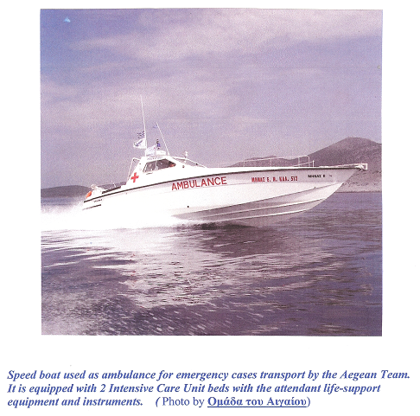

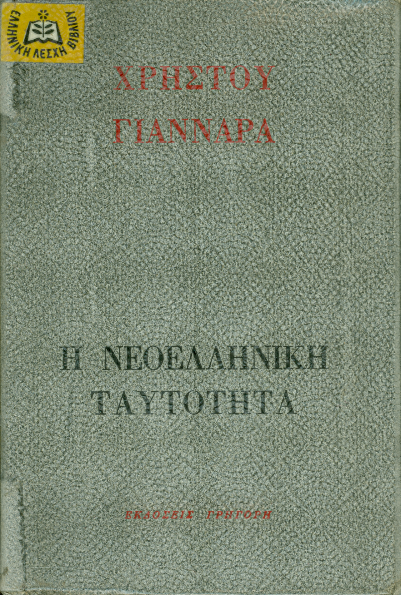

B 7K101 "The modern Greek identity"
Christos Giannaras
Ed. "Grigori"
Sociological essays – 230 pages – 14x21

The voices of many intellectuals are being heard in a desperate appeal, because the character of modern Greeks is being decisively altered and they are losing their identity. One of the most representative voices expressing this concern is that of the author himself, who makes an in-depth investigation of the problem, in its psychological, personal, political, and social dimensions. His topics include: "Orthodox Greek tradition and consumer culture"; "Capitalism and the awareness of mortality"; "The political content of religious indifference"; "Greece and the West"; "The inferiority complex of Modern Greeks"; "A fiesta through failure". No program and no revolution can deal with the reality of crippled humans born through the culture of capitalism and its impersonal mechanistic functions … Only the radical existential attitude and action, that gives absolute priority to the achievement of people's personal truth, may confront the hypnotic illusions of prosperous consumerism".
Panagiotis Rozakis

Hellenic Book Club Selection of the Month

QUALITY BOOKS
Recommended by the Hellenic Book Club, A voluntary, non-profit organization
15, D. Solomou Str. 154 51 Athens, Greece Tel. 210 646-3888, 646-3263fax
info@elbi.gr wwww.elbi.gr

Professionals and students in every discipline or field of endeavor, whether of Greek Descent or Philhellenes, are cordially invited to join the Hellenic Link, Inc. as members. It is quite easy and useful! Just contact us at any of the following addresses:

THE HELLENIC LINK, Inc.

A NON PROFIT CULTURAL AND SCIENTIFIC ASSOCIATION

OF HELLENES AND PHILHELLENES

INCORPORATED IN DELAWARE

Suite No. 278, 38-11 Ditmars Blvd, Astoria, New York 11105
Web Site: http://www.helleniclink.org Email: info@helleniclink.org

Contact Telephone : (718) 217- 4285

